Basic Atomic Theories and Particle Physics (Expanded Version)

1. Introduction
This expanded document provides deeper coverage of the major atomic theories that developed over time, leading into the foundations of particle physics and the Standard Model. It includes historical developments, equations, and clear visual diagrams to support the concepts.

2. History and Evolution of Atomic Theories

2.1 Dalton's Atomic Theory (1803)
John Dalton proposed the first scientific atomic theory. He stated that:
• Matter is made of indivisible atoms.
• Atoms of the same element are identical.
• Atoms combine in whole-number ratios to form compounds.
• Chemical reactions rearrange atoms but do not create or destroy them.

2.2 J.J. Thomson’s Plum Pudding Model (1904)
Thomson discovered the electron using cathode ray experiments. He proposed that the atom was a sphere of positive charge with negatively charged electrons embedded within it—similar to raisins in a pudding.

2.3 Rutherford’s Nuclear Model (1911)
Rutherford’s gold foil experiment showed that atoms have a dense, positively charged nucleus. Most of the atom is empty space, and electrons orbit the nucleus at a distance.

2.4 Bohr’s Model (1913)
Niels Bohr introduced quantized orbits for electrons. Electrons can only occupy fixed energy levels, and transitions between levels emit or absorb photons of discrete energies.
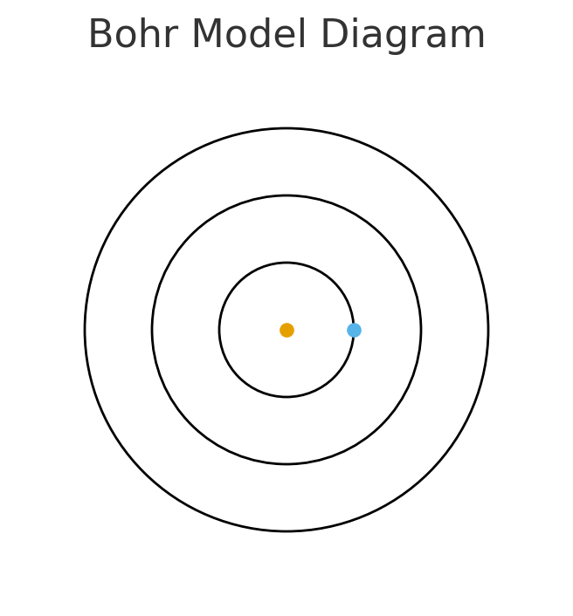
Figure 1: Representation of Bohr’s quantized orbits.

2.5 Quantum Mechanical Model (Modern)
Developed by Schrödinger, Heisenberg, and others, this model replaces fixed orbits with probability-based electron clouds. It incorporates wave-particle duality, uncertainty principle, and complex mathematical wavefunctions that describe electron behavior.

3. Key Mathematical Formulas
• **Bohr Radius:** a₀ = 4πɛ₀ħ² / (mₑe²)
• **Hydrogen Energy Levels:** Eₙ = −(13.6 eV)/n²
• **de Broglie Wavelength:** λ = h/p
• **Schrödinger Equation:** ĤΨ = iħ ∂Ψ/∂t
• **Heisenberg Uncertainty Principle:** Δx·Δp ≥ ħ/2

4. Introduction to Particle Physics
Particle physics goes beyond atoms, studying fundamental particles such as quarks, leptons, and bosons. These particles make up all known matter and mediate the fundamental forces.
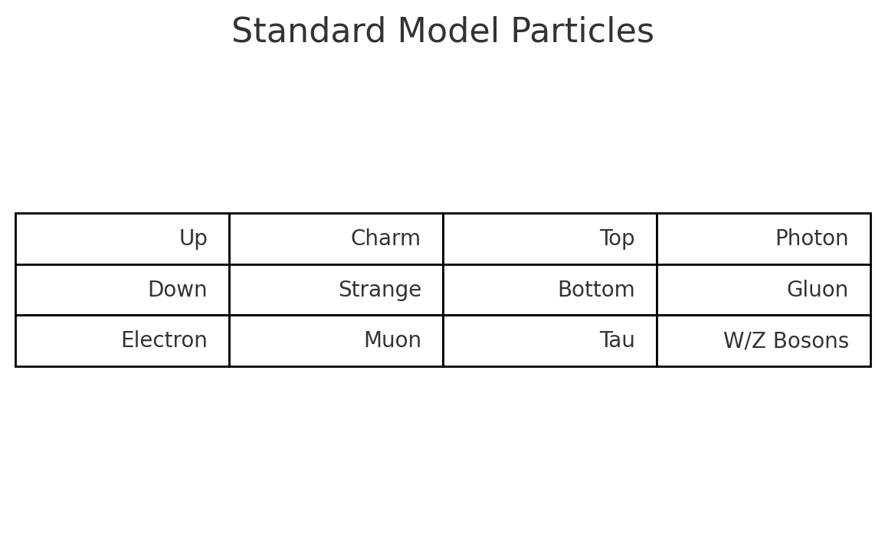
Figure 2: Simplified Standard Model chart.

5. Applications
• Nuclear power generation
• Radiation therapy and medical imaging
• Semiconductors and electronic devices
• Particle accelerators (e.g., CERN)
• Space science and cosmology

6. Conclusion
From early philosophical ideas to quantum mechanics and high-energy physics, our understanding of atomic structure has progressed dramatically. These theories not only shaped modern physics but also enabled technologies that power the modern world.

